HK INSTITUTE OF VOCATIONAL EDUCATION
DEPARTMENT OF INFORMATION AND COMMUNICATIONS TECHNOLOGY

ITP4910 Software Development Project

LAB 02 – C # Basic Controls

Objectives:
- To learn what event and event handling are
- To learn the basic controls (Radio Button, Picture Box and List Box) in C#

In the last lab session, we have asked you to double-click on the button to activate your code window. The following codes appeared automatically.

private void button1_Click(object sender, EventArgs e)
{

}

The above Method would be executed when the button was clicked. Different components have different kinds of events. You can create the respective event procedures through the 2 combo boxes at the top of your code window. You can call the code window out by clicking the left mouse button on the components you want. And then, you can choose the desired event from the right combo box. Alternatively, you can change to other components using the left combo box.

Part A: Radio buttons and Event Procedure

- Create a new project of type Windows Applications. Enter Lab02 as its name.
- Insert these objects into the form:
- A label with the text property set to “Qty”.
- 3 radio buttons with suitable text such as Red Wine ($250), grouped into a Group Box
- Another 2 radio buttons for the payment method grouped into another Group Box
- A button control with text set to “Calculate”.
- A label for displaying the total. (Note: You may want to change the border property)

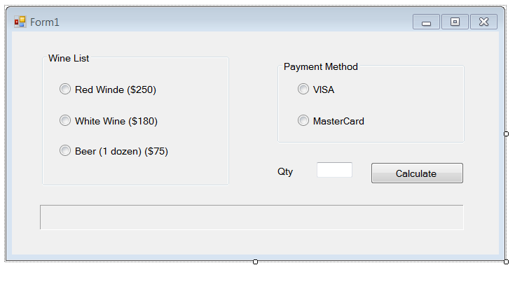

- The program to display the total in the label when a radio and the calculate buttons are clicked is as follows:

namespace Lab02 {
public partial class Form1 : Form {
private int price;
private string payment;

public Form1() {
InitializeComponent();
}
private void radioButton1_CheckedChanged(...) {
price = 250;
}
private void radioButton2_CheckedChanged(...) {
price = 180;
}
private void radioButton3_CheckedChanged(...) {
price = 75;
}
private void radioButton4_CheckedChanged(...) {
payment = "VISA";
}
private void radioButton5_CheckedChanged(...) {
payment = "MasterCard";
}
private void button1_Click(...) {
// Try to implement it yourself
}
}
}

Complete the coding and test your program.

Remember to add the statements at the top of the program,

private int price

private string payment
- Insert the appropriate statements such as price = 250 in each of the mthod for the radio buttons.
- In the Method button1_Click, insert the statement to calculate the total price.

Hints:
- As you can see in the above program segment, we use // for comment.
- To concatenate the strings in C#, we use the symbol “+”
Example: output = “Hello World!” + “ My Good Boy.”
- The string in text box should be converted to numeric values when you are doing calculations.
- You can use the built-in function String.Format to format the total amount.

Part B: Picture Box and Key Control

- Create a new form named Form2 with text “Weather Report”. When running your Form2, remember to change the start-up form of your project to Form2.
- Add two labels, one textbox, one group box, four radio buttons, four picture boxes on Form 2 as follows.
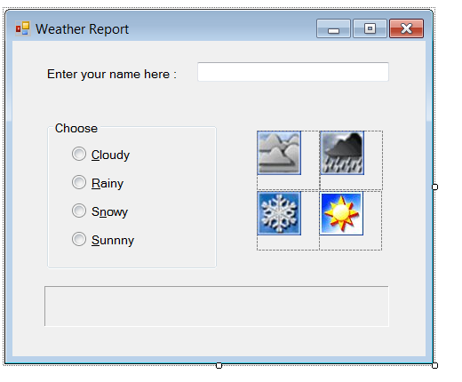

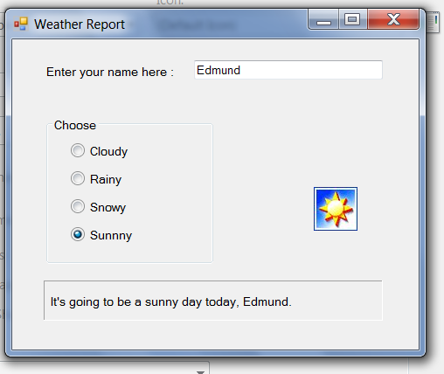

The following shows a part of the code when the Sunny radio button is clicked

private void rdoCloudy_CheckedChanged(...) {
// Display the cloudy message

picCloudy.Visible = ???;
picRainy.Visible = ???;
picSnowy.Visible = ???;
picSuny.Visible = ???;
lblMessage.Text = “It’s going to be a cloudy day today, “ + txtName.Text + “.”;
}

Try to finish the event procedures for the other radio buttons.

Remarks : Sometimes it is preferable to use the keyboard instead of the mouse. You can enable keyboard access for a button by placing an & in the text property.
e.g. &Cloudy will allow you to select the radio button by typing Alt-C.

- If you have time left, set the tab order of the controls (text boxes, labels, and etc) using the tab index.

Part C: List Box Control

- Create a new form named frmStudents with text “Students”. When running your frmStudents, remember to change the start-up form of your project to frmStudents.

- Add two labels, one button and one list box on frmStudents. Set their properties according to the following table.

Object | Object Name | Property | Setting
Form | frmStudents | Text | Students
List Box | lstStudents (small L, not numeric 1) | Sorted | True
TextBox | txtName | Text | ** keep it blank
Button | btnAdd | Text | Add Item
Label | lblDelete | Text | [Double-click to delete.]
Label | lblMessage | Text | ** keep it blank

RESULT (when running):
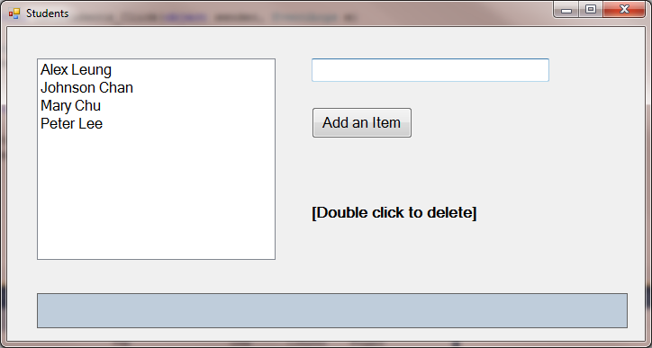

- Adding Items to List
- Study the following procedure

Action | Syntax
Add a string (item) to a list | lstBox.Items.Add(str)

- Double click on the form
- Right click and choose “View Code”.
- Select the method “frmStudents_Load”.
- Insert the following statements into frmStudents_load method

lstStudents.Items.Add("Mary Chu");
lstStudents.Items.Add("Peter Lee");
lstStudents.Items.Add("Johnson Chan");
lstStudents.Items.Add("Alex Leung");

- Run and test the program.

- Deleting an Item from the list
- Study the usage of RemoveItem and ListIndex procedures

Action | Syntax
Remove the item obj from list | lstBox.Items.Remove(obj)
Return the currently highlighted item in the list box | lstBox.SelectedItem

- Add the following statement in lstStudents_DoubleClick to delete the selected item.

lstStudents.Items.Remove(lstStudents.SelectedItem)

- In that procedure, show a message like the following in your label:

The following item is deleted: Alex Leung

- Run and test the program.

- Displaying the Selected Item in the list
- The selected item in the list box will be automatically converted into text string when it is manipulated with string functions.
- When the user selects an item on the list box, the “click” event happens. Which procedure will be executed automatically?
- In that procedure, show a message like the following in your label:

The following item is selected: Peter Lee

- Run and test the program.

- Adding an item specified by the user
- Add the statements to the btnAdd_Click event to add txtName into the List Box.
- In that procedure, show a message like the following in your label:

The following item is added: Tom Chan

- Run and test the program.

